A Project Report on

DISSECTING THE DIGITAL LANDSCAPE:

A comprehensive Analysis of social media.

**by**

**Team Leader: GUMADALA SIVATHANUSRI (20AT1A05E7)**

**Student 1 T.H SRIYA (20AT1A05F9)**

**Student 2 RODRAS SUPRIYA (20AT1A05G5)**

**Student 3 TADIKMELLA SRIDIVYA(20AT1A05F4S)**

**Under the Guidance of**

**MRS.M. JAYA SUNITHA, MTech**

**Associate Professor**



**DEPARTMENT OF COMPUTER SCIENCE ENGINEERING**

**G. PULLAIAH COLLEGE OF ENGINEERING AND TECHNOLOGY**

**(Autonomous)**

(Approved by AICTE | NAAC Accreditation with ‘A’ Grade | Accredited by NBA (ECE, CSE, EEE, CE) |

Permanently Affiliated to JNTUA)

ABSTRACT

Social media is a technology that can be developed in a fast and flexible manner, where internet connections are transformed into interactive platforms. Social networking programs are increasingly spreading around the world. Facebook users reached 1.44 billion per month in 2015, which means that most of the people of the world have a stamp on social networking platforms. Social media platforms have become integral part of teens' daily life. 22% of teenagers are enrolled in social networking programs about 10 times a day. The remaining category, which makes up more than half of teenagers register more than once a day through the use of mobile phone, where the proportion of teenagers who have their own cell phones reach 75%. The results show by RSA that the rate of cybercrime reached 173% by mobile phones during the period 2013–2015. And, the RSA announce a large number of real examples of cybercrime that have occurred recently and continue to pose a major threat to society and specific to teenagers. Consequently, this paper review social media, society and business. Moreover, how he social media impact teenagers.

**Contents**

**Abstract** 2

**Contents** 3

**List of Figures and Tables** 4

**CHAPTER 1 INTRODUCTION 4-5**

**CHAPTER 2 LITERATURE REVIEW 6**

**CHAPTER 3 PROPOSED METHOD 7**

**CHAPTER 4 EXPERIMENTAL RESULTS 8-11**

**CHAPTER 5 APPLICATIONS/ADVANTAGES 12-13**

**CHAPTER 6 CONCLUSIONS & FUTURE SCOPE 14**

**LIST OF FIGURES AND** **TABLES**

Database collected from IBM cogon’s about the DISSECTING THE DIGITAL LANDSCAPE: A comprehensive Analysis of social media.

**CHAPTER 1**

**INTRODUCTION**

Social media network is known as content that is posted on web platforms and the contents of these platforms differ from one region to another. Before the advent of these platforms, communication was either private messages or public media. But now, it is reflect what we are today socially and how it has topped the world social groups in the public and private sectors and it is not just communication. In addition, the recent changes in the uses of the internet and websites have become a detection identity as missuse, afraid of the loss of social privacy. [1] Social networking sites are Web-based platforms that allow people to create their own profile, which allow user to determine their account characteristics according to their personal preferences to be public or private. The user also has a list of people who share and follow up with him. It is called “social networks” where the word network means relationship even new relationships or closer relationships. While the “social” refers to continuity in communication, the main objective of social networks programs is to allow relationships built even at the social level or with new strangers

**What is social media?**

Social media is a collective term for websites and applications that focus on communication, community-based input, interaction, content-sharing and collaboration People use social media to stay in touch and interact with friends, family and various communities. Businesses use social applications to market and promote their products and track customer concernsSocial media has enormous traction globally. Mobile applications make these platforms easily accessible. Some popular examples of general social media platforms include Twitter,Facebook and Linked In.

**What are the benefits of using social media?**

### **1. Direct Contact With Target Audience**

Thanks to social media platforms, you don't have to call or email people randomly to check if they are interested in your brand or not. With almost the whole world on social media, it is now possible that your target audience is simply a click away from you. Using hashtags, you can directly land your brand on your target audiences' page - giving yourself an enormous reach.

### **2. Increasing Popularity With Ease**

For people in the content and digital marketing arena, the ability to attract popularity is what matters most. The social media platforms provide such a section of people with precisely what they're looking for - increased exposure. Carrying out simple, engaging tasks such as answering queries, posting times, and so on would ensure that you blow up on these sites after some time. Even though it requires some time investment, the hefty returns are worth it at the end of the day.

### **3. Better Traffic**

Since there is a wide diversity of active people on social media, the scope for diverse traffic is also broadened. Optimizing social media per your needs can ensure that you receive visits and traffic from various people. Since today people are on their phones most of the time, it is highly likely that people would come across your brand or work. Proper usage of keywords and other  SEO guidelines would also ensure heavier and better traffic.

**CHAPTER 2**

**LITERATURE REVIEW**

* In today’s digital environment businesses face the challenge of effectively utilizing social media platforms for marketing purposes. To overcome this challenge, a comprehensive analysis of digital landscape is needed to maximize social media marketing strategies.
* Various Business Problems are.
* Insufficient measurement and analytics.
* Inefficient Resource allocation
* Poor Audience Targeting
* Platform Selection
* Unclear Objectives
* Limited Awareness
* The popularity of social media sites has been steadily increasing over the last few years, and over 70 % of online adults are now using a social networking site of some kind. Many users of social networking sites have more than one account, and check these accounts several times daily [[6](https://link.springer.com/chapter/10.1007/978-3-319-20367-6_11#ref-CR6)]. But even as social media has been widely adopted by many users, its use for higher education has also been questioned by educators. Although faculty in higher education often utilizes social networking sites in a professional context, many are reluctant to use social networking sites for teaching and learning. Moreover, even though computing faculty members may have more experience with the technology, their adoption of social media for teaching purpose has been at a lower rate comparing to faculty in other fields such as Humanities and Arts, Professions and Applied Sciences, and Social Sciences [[6](https://link.springer.com/chapter/10.1007/978-3-319-20367-6_11#ref-CR6), [20](https://link.springer.com/chapter/10.1007/978-3-319-20367-6_11#ref-CR20)].
* Web 2.0 (often referred to as the “social web”), with its many benefits such as social networking and user-generated content, has drawn much attention for teaching and learning [[2](https://link.springer.com/chapter/10.1007/978-3-319-20367-6_11#ref-CR2)]. Learning paradigms have shifted over the last decades from a traditional classroom setting to include online learning, e-learning, collaborative learning, and many hybrid forms. This shift indicates a move from instructor-led and instructor-cantered learning environments to learner-cantered environments, which focus on knowledge creation and building rather than knowledge transmission [[3](https://link.springer.com/chapter/10.1007/978-3-319-20367-6_11#ref-CR3), [5](https://link.springer.com/chapter/10.1007/978-3-319-20367-6_11#ref-CR5)]. At first glance, Web 2.0 applications such as social networks, wikis, blogging, and micro blogging seem to be well suited for learner-cantered environments, but a closer look reveals that the adoption of Web 2.0 technologies and applications in higher education learning is lagging behind the adoption of Web 2.0 technologies overall. Although roughly 90 % of young adults (18-29 years old) use some social network site, many faculty members also see limitations and potential problems with the use of online and interactive technologies.

**CHAPTER 3**

**PROPOSED METHOD**

* How do businesses leverage social media for marketing and customer engagement?
* What are the advertising models and monetization strategies employed by social media platforms?
* How can businesses effectively reach and engage with their target audience through social media?
* Sentiment analysis: displays the sentiment of social media data, showing proportion of positive, negative and neutral sentiment in conversation.
* Heart Maps: displays geographic distribution of social media data, showing where Conversation and engagement are happening in real time. This can help to identify regional trends.

Customer Satisfaction:

* By analyzing the behavior of the user on the platform, business organizations target their customer based on their interests.

Business Model:

* By analyzing social media engagement and user behavior, business can optimize their advertising campaigns to reach their target audience more effectively.

Scalability of the Solution:

* Audience size and engagement metrics.
* Customer feedback.
* Competitor analysis.
* Market trends.
* Expanding production.
* Increasing marketing efforts.

**CHAPTER 4**

**EXPERIMENTAL RESULTS**

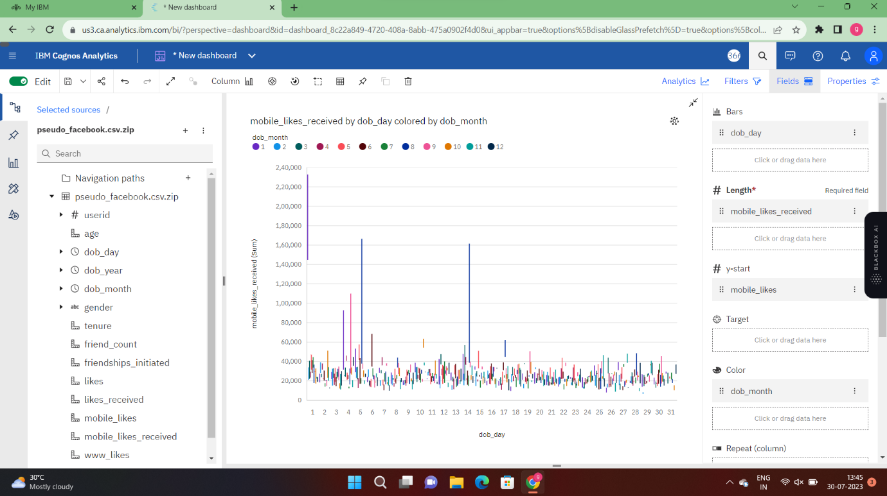

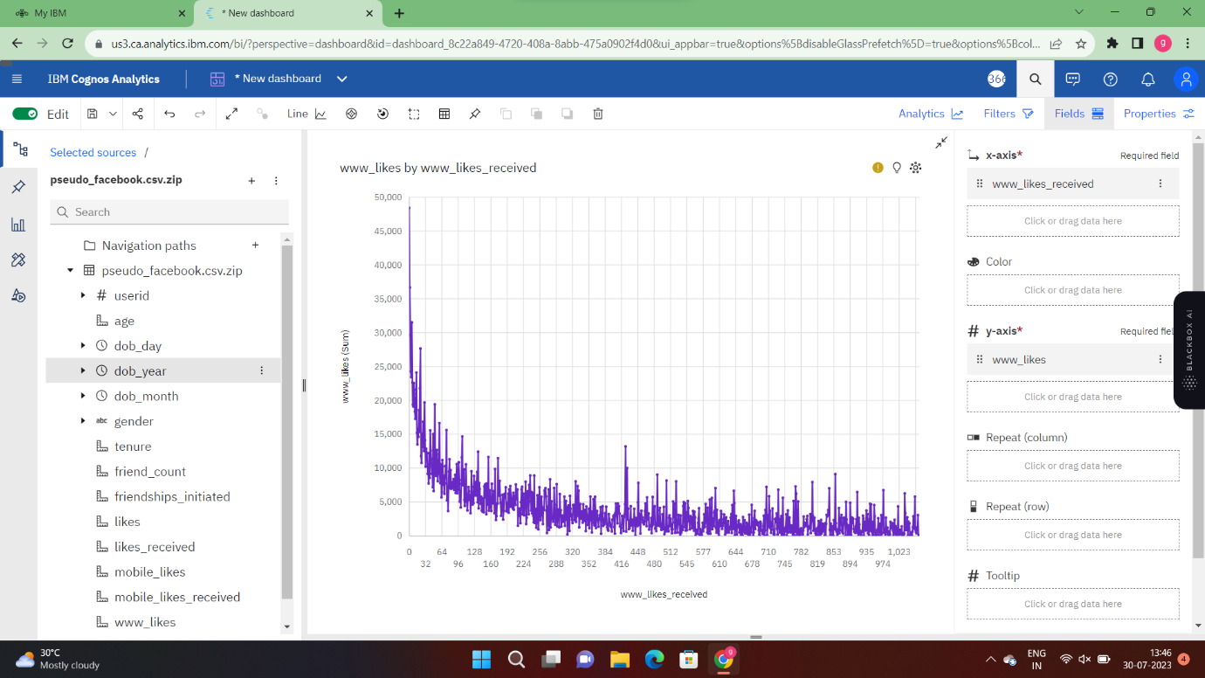

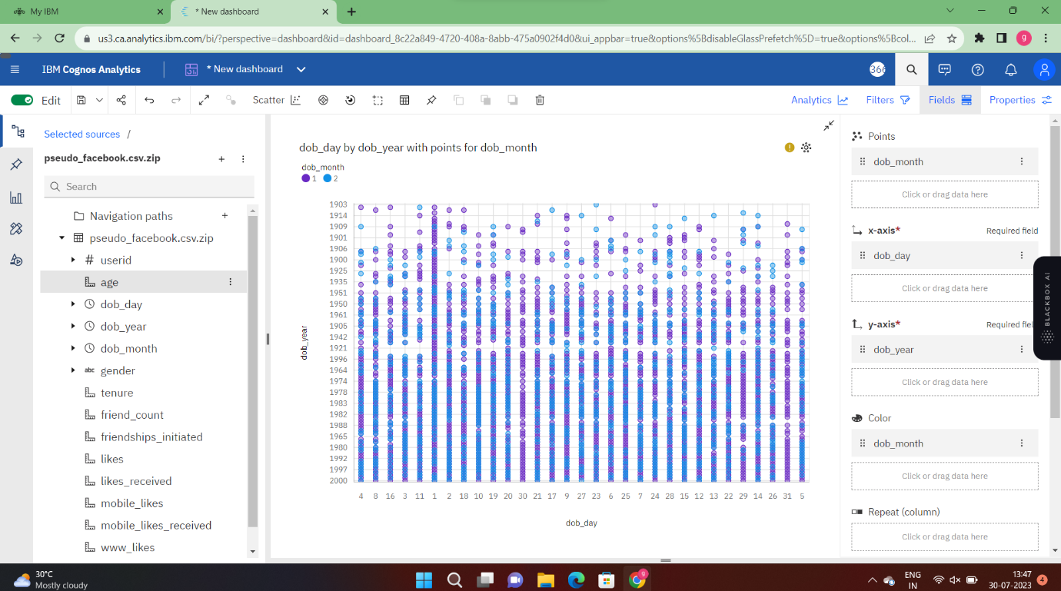

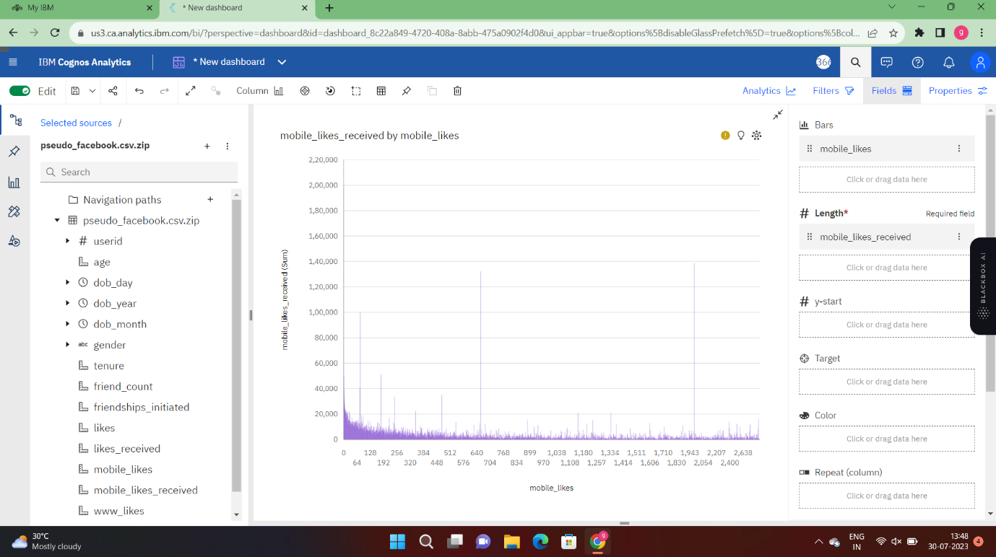

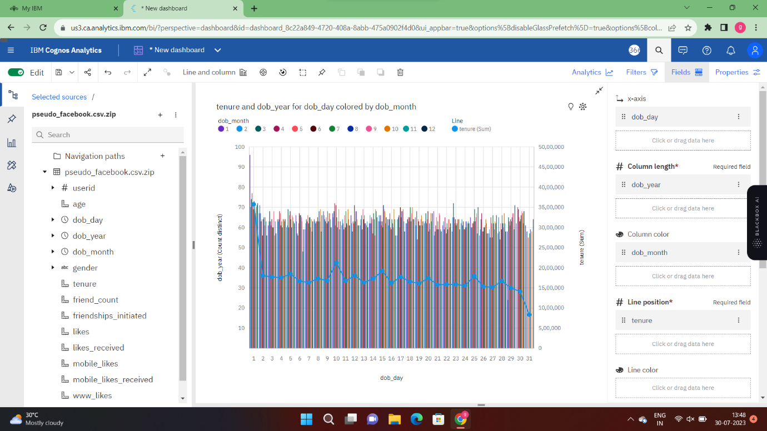

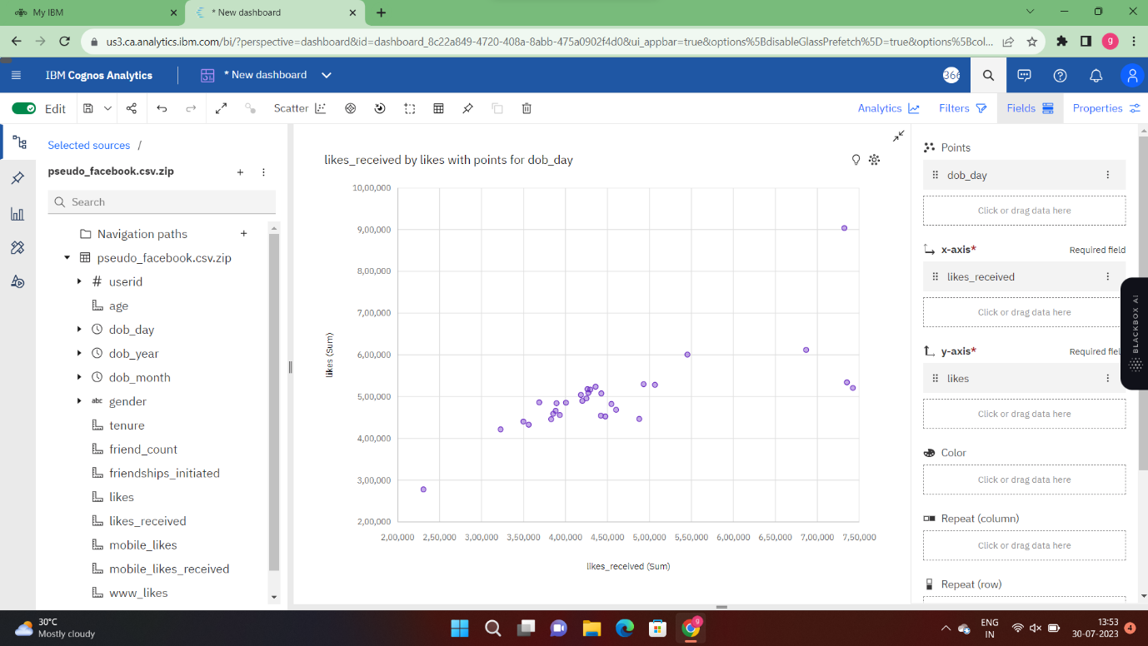

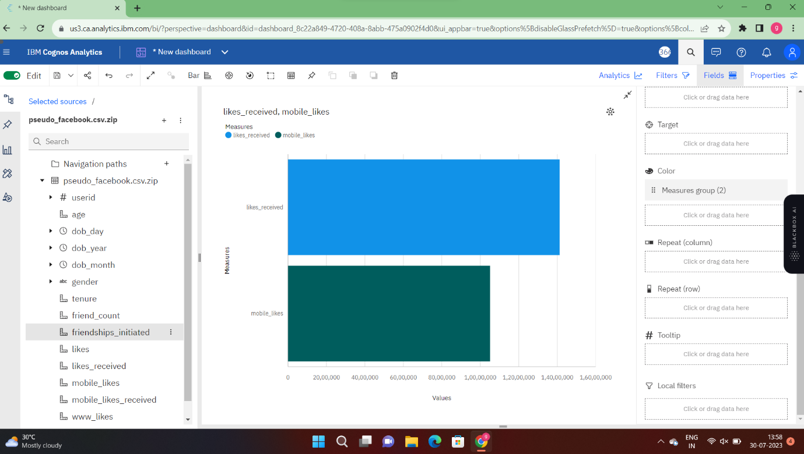

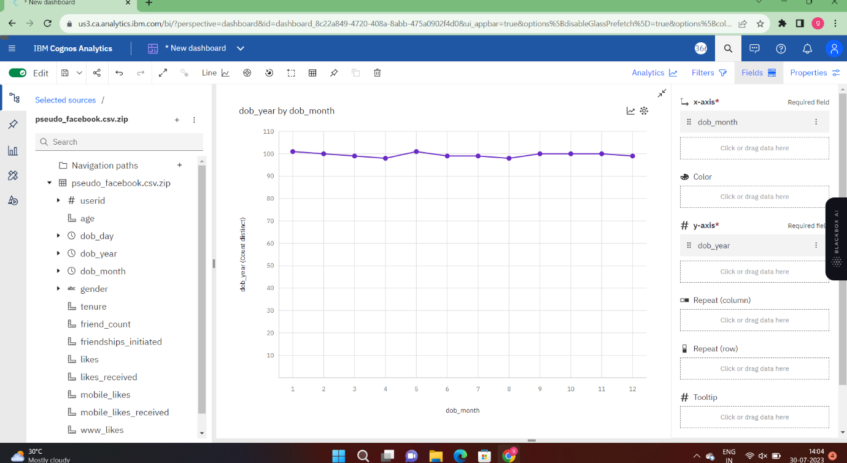

**CHAPTER 5**

**APPLICATIONS/ADVANTAGES**

**ADVANTAGES**

1. Connectivity
2. Education
3. Awareness
4. Help in building communities
5. Promotion
6. Customer Interaction

**DIS ADVANTAGES**

1. Affects Social-Emotional Connection
2. Decreases Quick-witted Skill
3. Causing Distress to Someone’s feelings
4. Present Physically Not Mentally
5. Lack of quality family time
6. Cyberbullying

**APPLICATIONS**

Every web-based-application that supports information publishing and sharing (text, video, audio, photo), the building of personal profiles, connecting to a community and searching within the community is considered as a social media application.

Applications / social media

1. Facebook.
2. Twitter
3. LinkedIn
4. Snapchat
5. TikTok
6. Reddit
7. Tinder
8. Discord
9. Whatsapp
10. Youtube

**CHAPTER 6**

**CONCLUSIONS & FUTURE SCOPE**

**CONCLUSION**

Social media is a really convenient and important communicate network for all the people nowadays. We can use it to know friends and keep contact with friends that came from different countries. We can also share our ideas so quickly so that all the things could develop so fast because people could tell us their ideas and we could improve it immediately. We could also learn new things on social media by watching or reading the things that people shared onto the social media. People could also sell things on social media freely which could reduce the expenditure of advertisements.

**FUTURE SCOPE**

The scope of social media in India is immense and increasing rapidly. It is the 10th biggest economy and also has the 2nd largest population in the world.  A survey in 2019, which includes the top businesses admitted that 15-20% of their marketing budget is allocated for social media advertising. From that, it is understood the importance of social media in brand advertising.

There will not be any person who doesn’t know what social media is. Isn’t it? But many individuals may not know how it is important in digital marketing and how[social media marketing](https://avivdigital.in/social-media-marketing-strategy/) can enhance career growth.  Based on the Statista analysis it is been found that the number of users of the social network in India will be 258.27 million. It is a drastic rise from approximately 168 million users in 2016.

India is encountering development in the number of mobile users; regardless it contains just 16 percent of the nation’s aggregate populace with access to the web. In addition, it is assessed that India’s web clients will end up noticeably the world’s biggest web base, after China and the US.

Inference

IBM Database extracted from smart internz.

Google.